**CONTENTS**

1. **NETWORK CONFIGURATION AND OPEN SOURCE SOFTWARE**
2. **STRUCTURED QUERY LANGUAGE (SQL) QUERIES**
3. **WEB APPLATICIONS**
4. **GUI APPLICATIONS**
5. Design a GUI application to read Price per dozen ( TextField) and Price per dozen (Text field) and calculate total payable amount( price *dozens) in a TextField on the click event of calculate Button. Also place two more buttons “Clear Text Box” and “Exit”. Write code to clear text fields on the click event of “Clear Text Box” and close application on the click event of “Exit Button”
6. Design a GUI application to enter two numbers (both Text Fields) and place 5 buttons to add, subtract, multiply , divide and to find out reminder. Display the result of above operation in another text Field.
7. Design a GUI application to read day number in a text field. Place a command button “Calculate Day Name”. Display equivalent day name on the click event of “Calculate Day name” in a text field.
8. Design a GUI application to read price of a pizza (Textfield) and total order quantity ( TextField). And two radio button 1- 5% discount 2- 90% discount and 3 command button on the frame. 1- Calculate Bill 2- Clear Text 3. Close App. Calculate Total payable amount on the click event of “Calculate Bill”, Clear all the text fields on the click event of “Clear Text” and close application on the click event of “Close app”.
9. Design a GUI application to join your first name( TextField) and second name ( Text Field). Join these names on the click event of button “Join Names” and display them in a third Text Field (Disable).
10. Design a GUI application in netbeans to calculate the amount payable by the customer as per the following GUI. The rate of extra toppings are given in the brackets and any applicable discount. You are required to write the code on the click event of “calculate bill”.
11. Design a GUI application to read Roll Number, name of student and marks obtained in five subject in text Fields. Calculate Total marks and grade on the click event of “Calculate” and display them on the text Fields.
12. Design a GUI application to read three numbers ( in TextFields) from the keyboard and calculate the largest number among them. Display the result in Text Field.
13. Design a GUI Application(Append) to read your name( Textfield) , roll Number ( TextField), Class ( TextField) marks obtained in English ( TextField), Accounts ( TextField), Business Studies (TextField), Economics ( Textfield) and informatics Practics( TextField). Using JTextArea’s Append methods display all the inputted information in TextArea on the click event of “Add Information” button.
14. Design a GUI application to read starting number( TextField) and end number (Text Field). Generate all the number between these two numbers and display them in a TextArea on the click event of “generate series” button.
15. Design a GUI application to insert record in the table school.
16. Design a GUI application to show all the records of the student table in application in table format
17. Design a GUI application to search a record in the above generated table student. If the record exist then delete that record from the table.
18. Design a GUI in application to search a record in the above generated table student. If the record exist then UPDATE that record from the table ( Screenshot is for reference purpose) otherwise display a popup message “record does not exist”. Modify button only enable if the record exist in the database otherwise it remains disable.
19. ABN Corporation impose charges on customer for different products .The shipping company costs for an order in two forms 1.- Wholeseller 2- retailer. Total cost on the click event of “Calculate” button and also display discount and total cost in textfields.
20. Mr XYZ visited mahagun mega mall. His family purchased some products form mahagun metro mall. The mall have some attractive discount for credit cards holders. You are requested to calculate the discount on total amount ( enter in text field) and calculate discount as per the given criteria table.
21. Ms Vidhyarthi is Working in DAV Centenary Public School Chander Nagar as a programmer. She was asked to develop a GUI in netbeans to develop an application. The school offers two streams – 1 Medical 2- Non Medical with the grading criteria.

**NETWORK CONFIGURATION AND OPEN SOURCE SOFTWARE**

**What is a Network?**

A **computer network** is a collection of interconnected computers and other devices which are able to communicate with each other and share hardware and software resources.

**Why do we need networks?**

* **Resource Sharing:** data, hardware and software resources can be shared irrespective of physical location.
* **Reliability:** file can have two or more copies on different systems, in case if one is unavailable we can use the other.
* **Reduced costs:** sharing of resources, reduces cost.
* **Fast communication:** exchange information fast.

**Evolution of Network**

US DOD started ARPANET , which was to connect computers at different departments In mid 80’s NSFnet(National Science Foundation Network) was formed and in 90’s Internet evolved.

**What are nodes or Work stations?**

The different terminals which are attached to the network and share the resources of the network are called nodes.

When we attach a computer with the network it becomes the workstation of that network.

**What is a server ? What is its types?**

To designate a particular node,which is at a well known and fixed address, to provide a service to the n/w as a whole.The node providing the service is known as the **server**. A computer that facilitates the sharing of data, software and hardware resources on a network, is called server. It can be of two types.

**Non-dedicated server -** It is a workstation on a small network that can also act as a server. It is not dedicated to the cause of serving.

**Dedicated server -** On bigger networks, a computer is reserved for the cause of serving which is called a dedicated server. Dedicated only to facilitate resources.

**Proxy Server-** A machine that is not actually a server but appears as a server.

**Types of Network:-**

**Local Area Network (LAN)** -Connects computers in a limited geographical area such as a building or an office. Each computer and device is a node .Total area is not more than 1 km. Software applications and other resources are stored on a ***file server***. Data communication is at rate of 100 Mbps. It is owned by a single organization. Error rate is much lower in LAN.

**Metropolitan Area Network (MAN)-** High-speed network that connects LANs in a metropolitan area. Covers a group of nearly corporate office or a city. Can support both data and voice.

**Wide Area Network (WAN)-**Connects computers and devices in a large geographical area. Connected via many types of media. One large network or two or more interconnected LANs, MANs. Data can be communicated to the far –flung areas with the help of satellites. It uses packet or message switching method and uses fibre optical cables. It operates at a speed of less than 1mbps.

**Personal Area Network (PAN) -**Refers to a small network of communication capable devices within a range of reach ability of an individual person. Range is typically upto 10 meters. Ex. Two cell phones through Bluetooth forms a PAN.

**Network Interface Unit(NIU) or NIC(Network Interface Card) or TAP(Terminal Access Point)**

A Network Interface Unit(NIU) is an interpreter that helps establish communication between the server and workstations. It is a device **Network Interface Card (NIC)** that is attached to each of the workstations and the sever to establish the all-important connection with the network. NIC manufacturer assigns a unique physical address to each NIC card known as MAC address(Media Access Control) e.g. **MM:MM:MM:SS:SS:SS**

**MODEM**(Modulation /Demodulation)-converts data from digital to analog and vice versa. When we use analog facility for data communication between two digital devices we require two modems one near each digital devices.

**RJ-45 (Registered Jack)** is an eight wire connector, used to connect computers on LAN especially Ethernet.

**Repeater**- When a signal travels a long distance, it tends to lose strength. So, repeater strengthens or amplifies and then retransmits a signal being transmitted on a n/w. It is used for distance greater than 70 m or 100 mts.

**Hub**- It is a hardware device used to connect several computers together. They are multi slot concentrators into which a number of multi-port cards can be plugged to provide additional access as the network grows in size. Hubs are of two types:

**Active Hubs**- It amplifies signal as it moves from one device to another.

**Passive Hubs**- It allows the signal to pass from one computer to another without any change.

**Problems with Hubs-**

1. Share bandwidth among all attached devices.

2. Cannot filter traffic & causes network traffic jam.

**Bridge (smart HUB)**-Bridge is a device that is used to link or connect two networks together i.e. a smaller no. of individual networks with **same protocols** to make them work together as one large n/w. Bridges are smart enough to know which computers are on which side of the bridge, so they only allow those messages that need to get to the other side to cross the bridge. It examines the **physical destination address** of the packet. **It can filter n/w traffic based on MAC address). It connects two different types of cables (like Optical Fiber, Twist-pair cable).**

**Switch(multi port bridge)**: It is responsible for filtering (i.e. transforming data in a specific way) and for forwarding packets of message being transmitted, between LAN segments. It is a device used to segment networks into different sub networks called subnets. Segmenting the network into smaller subnets **prevents traffic overloading** in a network.

**Router**-is a device that not only can be used to link or connect a smaller individual n/ws but it can handle **different protocols**. **It filters traffic on the basis of IP address**(**logical address) & route the network traffic only to the segment where it is destined.**

**Gateway**-is a device that connects dissimilar n/ws (e.g. to link Mac n/w and a PC n/w).It establishes an intelligent connection between a LAN and external n/ws with completely different structure.

**Transmission Media - A transmission medium** is a medium of data transfer over a network. It can be wired (guided) or wireless(un-guided).



**TOPOLOGY**

**Physical arrangement of devices connected to the network. It is** the pattern of interconnection of nodes in a n/w is called the topology There are no. of factors which should be considered before choosing the topology(cost, flexibility and reliability.)

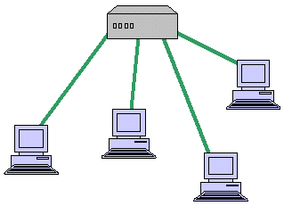**STAR TOPOLOGY**- It consists of central node to which all other nodes are connected by a single path.

**Advantages-**

1. Failure of a single connection typically involves disconnecting one node from an otherwise fully functional n/w because of **one device per connection**.

2. **Centralized control/problem diagnosis**. Ease in disconnecting the failing nodes.

3. Any given connection involves only the central node so **access protocols are simple**.

**4. Ease of service.**

**Disadvantages-**

1. **Long cable length** as each node is directly connected to the center.

2. **Difficult to expand** as addition involves a connection all the way to central node.

3. **Central node dependency,** if central node fails entire n/w is down.

**Open Source Concepts**

**Open Source Software**- Software whose source code is available and which can be modified copied and redistributed. It may be free of cost or not.

**Freeware**:-The software that is **free of cost** and can be **c**opied redistributed but can’t be modified because source code is not available. Right to use software is limited to certain type of users. E.g. Microsoft Internet Explorer.

**Shareware**: -It is offered as trial version (for limited period of time) with certain features only available after the license is purchased. EgWinZip. It can be redistributed but source code is not available.

**Proprietary Software**:-Software that is neither free nor open. Eg MS OFFICE

Its use is regulated and further distribution and modification is either forbidden or requires special permission by the supplier. Source code is not available.

|  |  |
| --- | --- |
| **Open Source Software** | **Proprietary Software** |
| It comes at no initial license cost. | It has to be bought by paying initial license fee as it is a legal property of a person or a company that usually sells it at a price |
| It allows a user to customize the software according to its need. | Here customization is not possible at the user end as access to the source code is denied and solely controlled by the developer of the software. |
| Commercial support is optional | Commercial support is obligatory |
| Open standards that facilitate integration with other systems | It has closed standards that hinder further development. |
| Lack of professional support | professional support and training available |
| E.g Linux, MYSQL | E.g Microsoft Windows, Real Player, Adobe Photoshop, MAC |
| Source Code available for change | Source code not available for change |
| Can be copied & distributed | Cannot be copied / distributed |

**SOME EXAMPLES OF OPEN SOURCE SOFTWARE ARE:**

**GNU-** Not Unix

**Linux-** It is a **popular operating system.** It is the most common example of free software because it is freely available with source code. So that anyone can use it, modify it and redistribute and **can be downloaded from www.linux.org.**

**Mozilla**- Is a free, cross-platform internet suite, whose components include a web browser, an e-mail and news client, an HTML editor, and IRC client.

**Apache server**- The most common **web server (or HTTP server)** software on the Internet for online distribution of website services.

**Tomcat- Tomcat is a web server that supports servlets and JSPs.**

**PHP-**  PHP stands for **"PHP: Hypertext Pre-processor".** PHP is a **server-side scripting language for creating dynamic Web pages**. It is an open-source programming language which helps to develop server-side application and dynamic web content.

**Python- Python is a programming language**

**OpenOffice-** OpenOffice.org (abbreviated as 000) is a **free and open source office suite**.

**Apache Tomcat-** Apache Tomcat is a **web container** which is developed at Apache Software Foundation.

**MySQL- MySQL is a multi-user database management system.**

**STRUCTURED QUERY LANGUAGE (SQL) QUERIES**

**Question 1**

**Write the SQL commands for (i) to (iv) and outputs for (v) to (viii) on the basis of tables**

**BOOKS and ISSUES.**

**Table: BOOKS**

|  |  |  |  |  |  |
| --- | --- | --- | --- | --- | --- |
| **Book_ID** | **BookName** | **AuthorName** | **Publisher** | **Price** | **Qty** |
| **L01** | **Maths** | **Raman** | **ABC** | **70** | **20** |
| **L02** | **Science** | **Agarkar** | **DEF** | **90** | **15** |
| **L03** | **Social** | **Suresh** | **XYZ** | **85** | **30** |
| **L04** | **Computer** | **Sumita** | **ABC** | **75** | **7** |
| **L05** | **Telugu** | **Nannayya** | **DEF** | **60** | **25** |
| **L06** | **English** | **Wordsworth** | **DEF** | **55** | **12** |

**Table: ISSUES**

|  |  |
| --- | --- |
| **Book_ID** | **Qty_Issued** |
| **L02** | **13** |
| **L04** | **5** |
| **L05** | **21** |

**(i) To show Book name, Author name and Price of books of ABC publisher.**

**(ii) To display the details of the books in descending order of their price.**

**(iii) To decrease the Qty_Issued from ISSUES table by 3 (all rows must decrease).**

**(iv) To display the Book Id, Book name, Publisher, Price, Qty, Qty_Issued from both the tables with their matching Book ID.**

**(v) SELECT sum(price) FROM Books WHERE Publisher = “DEF”;**

**(vi)SELECT Publisher, min(price) FROM Books GROUP BY Publisher;**

**(vii)SELECT Price from Books, Issues where Books.Book_ID=Issues.Book_ID AND Qty_Issued=5;**

**(viii)SELECT Count(Distinct Publisher) FROM Books;**

**Question 2**

|  |  |  |  |  |  |  |  |  |  |  |  |  |  |  |  |  |  |  |  |  |  |  |  |  |  |  |  |  |  |  |  |  |  |  |  |  |  |  |  |  |  |  |  |  |  |  |  |  |
| --- | --- | --- | --- | --- | --- | --- | --- | --- | --- | --- | --- | --- | --- | --- | --- | --- | --- | --- | --- | --- | --- | --- | --- | --- | --- | --- | --- | --- | --- | --- | --- | --- | --- | --- | --- | --- | --- | --- | --- | --- | --- | --- | --- | --- | --- | --- | --- | --- |
| **Consider the following tables *STOCK* and *DEALERS* and answer the questions:**  **Table : STOCK**   |  |  |  |  |  |  | | --- | --- | --- | --- | --- | --- | | **Itcode** | **Itname** | **Dcode** | **Qty** | **unitpr** | **Stkdate** | | **444** | **Drawing Copy** | **101** | **110** | **21** | **31-July-2010** | | **445** | **Sharpener Camlin** | **102** | **235** | **3** | **01-Aug-2010** | | **450** | **Eraser Natraj** | **101** | **40** | **2** | **17-Aug-2010** | | **452** | **Gel Pen Montex** | **103** | **50** | **5** | **30-Dec-2009** | | **457** | **Geometry Box** | **101** | **35** | **45** | **15-Nov-2009** | | **467** | **Parker Premium** | **102** | **60** | **205** | **27-Oct-2009** | | **469** | **Office File** | **103** | **32** | **25** | **13-Sep-2010** | |
|  |
| **Table : DEALERS**   |  |  | | --- | --- | | **Dcode** | **Dname** | | **101** | **Vikash Stationers** | | **102** | **Bharat Drawing Emporium** | | **103** | **Banaras Books Corporation** | |
| **Write SQL commands for the following statements :** |
| **(i) to display details of all items in the stock table in descending order of Stkdate.** |
| **(ii) to increase unitpr (unit price) by 20% in the stock table for the items which has been purchased before 2010.** |
| **(iii) to display the details of those items whose Dcode (Dealer Code) is 102 or Qty (Quantity) is more than 50 from the table stock.** |
| **(iv) to display minimum unit price of items for each dealer individually as per Dealer Code from the table stock.** |
| **Give the output of the following SQL queries :** |
| **(i) SELECT COUNT(DISTINCT Dcode)FROM STOCK;** |
| **(ii) SELECT Qty*unitpr FROM STOCK WHERE Itcode=457;** |
| **(iii) SELECT Itname, Dname FROM STOCK S, DEALERS D WHERE S.Dcode=D.Dcode AND Itcode=450;** |
| **(iv) SELECT MAX(Stkdate) FROM STOCK;**  **Question 3**  **Consider the following tables Consignor and Consignee. Write SQL**  **commands for the statements (i) to (iv) and give outputs for SQL queries:**    **(i) To display the names of all Consignors from Mumbai.’**  **(ii) To display the CneelD, CnorName, CnorAddress, CneeName, CneeAddress for every Consignee.**  **(iii) To display consignee details in ascending order of CneeName.**  **(iv) To display number of consignors from each city,**  **Give the output of the following SQL queries:**  **(v) SELECT DISTINCT City FROM CONSIGNEE;**  **(vi) SELECT A.CnorName, B.CneeName FROM Consignor A, Consignee B**  **WHERE A.CnorID = B.CnorlD AND B.CneeCity = ‘Mumbai’;**  **(vii) SELECT CneeName, CneeAddress FROM Consignee WHERE CneeCity NOT IN (‘Mumbai’, ‘Kolkata’);**  **(viii) SELECT CneelD, CneeName FROM Consignee WHERE CnorID=’MU15' OR CnorID=’ND01';** |

**WEB APPLATICIONS**

**WEB PAGE 1-**

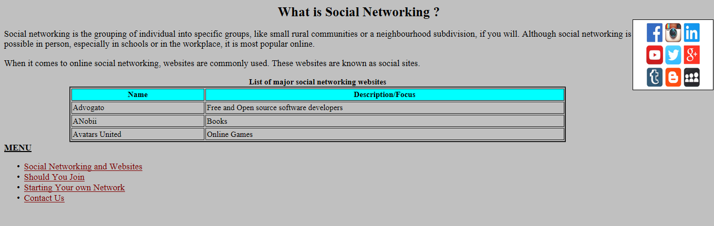

<HTML>

<HEAD>

<TITLE>Wildlife</TITLE>

</HEAD>

<BODY vLink=red aLink=blue link=Maroon bgColor=SilVer>

<FONT FACE ="Times New Roman" SIZE=2 >

<H1 align=center>What is Social Networking ?</H1>

</FONT>

<FONT FACE ="Times New Roman" SIZE=4 >

<Img align="right" border = "1" width=160 height=140 src="Image1.JPG">

<P align="justify">

Social networking is the grouping of individual into specific groups, like small rural communities or a neighbourhood subdivision, if you will. Although social networking is possible in person, especially in schools or in the workplace, it is most popular online.

</P>

<P align="justify">When it comes to online social networking, websites are commonly used. These websites are known as social sites.

</P>

<TABLE cellPadding=2 width="70%" align=center border=2 color="BLUE">

<CAPTION color="blue"><B>List of major social networking websites </B> </CAPTION>

<TBODY>

<TR>

<TH bgColor=cyan>Name</TH>

<TH bgColor=cyan>Description/Focus</TH>

</TR>

<TR>

<TD>Advogato</TD>

<TD>Free and Open source software developers</TD>

</TR>

<TR>

<TD>ANobii</TD>

<TD>Books</TD>

</TR>

<TR>

<TD>Avatars United</TD>

<TD>Online Games</TD>

</TR>

</TBODY>

</TABLE>

<U><B>MENU</B></U>

<UL>

<LI><A href="one.html">Social Networking and Websites

<LI><A href="two.html">Should You Join

<LI><A href="three.html">Starting Your own Network

<LI><A href="abc@xyz.com">Contact Us

</UL>

</BODY>

</HTML>

**WEB PAGE 2-**



<html>

<head>

<title>Garamani Campus</title>

</head>

<body bgcolor="white"><center>

<h1><font color="red">Garamani Campus</font> </h1>

<h3>Garamani Jhapa, Nepal</h3>

<h3>Phone: 24545454</h3>

<h2>Mail us</h2>

<form >

<label>Your Name: </label><input type="text"> <br>

<label>Your Email: </label><input type="email"> <br>

<label>Your Message: </label><textarea></textarea> <br>

<input type="submit" value="Send">

</form>

</center>

</body>

</html>

**GUI APPLICATIONS**

1.Design a GUI application to read Price per dozen ( TextField) and Price per dozen ( Text field) and calculate total payable amount( price *dozens) in a TextField on the click event of calculate Button. Also place two more buttons “Clear Text Box” and “Exit”. Write code to clear text fields on the click event of “Clear Text Box” and close application on the click event of “Exit Button”

ANS

Calculate Button

int a = Integer.parseInt(t1.getText());

int b = Integer.parseInt(t2.getText());

int c;

c = a*b;

resulttf.setText(""+c);

Clear Text Button

t1.setText("");

t2.setText("");

resulttf.setText("");

Close app Button

System.exit(0);

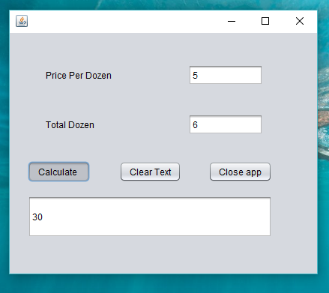

2.Design a GUI application to enter two numbers (both Text Fields) and place 5 buttons to add, subtract, multiply , divide and to find out reminder. Display the result of above operation in another text Field.

ANS

ADDITION button

DIVISION button

int a = Integer.parseInt(t1.getText());

int b = Integer.parseInt(t2.getText());

int c;

c = a-b;

t3.setText(""+c);

int a = Integer.parseInt(t1.getText());

int b = Integer.parseInt(t2.getText());

int c;

c = a+b;

t3.setText(""+c);

SUBSTRACTION button

REMAINDER button

int a = Integer.parseInt(t1.getText());

int b = Integer.parseInt(t2.getText());

int c;

c = a-b;

t3.setText(""+c);

int a = Integer.parseInt(t1.getText());

int b = Integer.parseInt(t2.getText());

int c;

c = a-b;

t3.setText(""+c);

MULTIPLICATION button

int a = Integer.parseInt(t1.getText());

int b = Integer.parseInt(t2.getText());

int c;

c = a-b;

t3.setText(""+c);

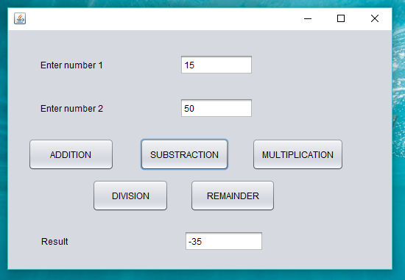

3. Design a GUI application to read day number in a text field. Place a command button “Calculate Day Name”. Display equivalent day name on the click event of “Calculate Day name” in a text field.

ANS

Calculate Button

int day = Integer.parseInt(t1.getText());

String ans;

switch(day){

case 1 : ans = "Sunday";

break;

case 2 : ans = "Monday";

break;

case 3 : ans = "Tuesday";

break;

case 4 : ans = "Wednesday";

break;

case 5 : ans = "Thursday";

break;

case 6 : ans = "Friday";

break;

case 7 : ans = "Saturday";

break;

default : ans = "Wrong day number";

}

t2.setText(""+ans);

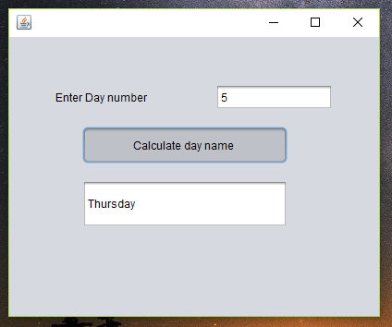

4.Design a GUI application to read price of a pizza (Textfield) and total order quantity ( TextField). And two radio button 1- 5% discount 2- 90% discount and 3 command button on the frame. 1- Calculate Bill 2- Clear Text 3. Close App. Calculate Total payable amount on the click event of “Calculate Bill”, Clear all the text fields on the click event of “Clear Text” and close application on the click event of “Close app”.

ANS

Calculate Button

Clear text button

t1.setText("");

t2.setText("");

t3.setText("");

b1.setSelected(false);

b2.setSelected(false);

int a = Integer.parseInt(t1.getText());

int b = Integer.parseInt(t2.getText());

int c ;

if

(b1.isSelected()==true)

c=(a*b)-(a*b)*5/100;

else if

(b2.isSelected()==true)

c=(a*b)-(a*b)*15/100;

Exit Button

System.exit(0);

else

c=a*b;

t3.setText(""+c);

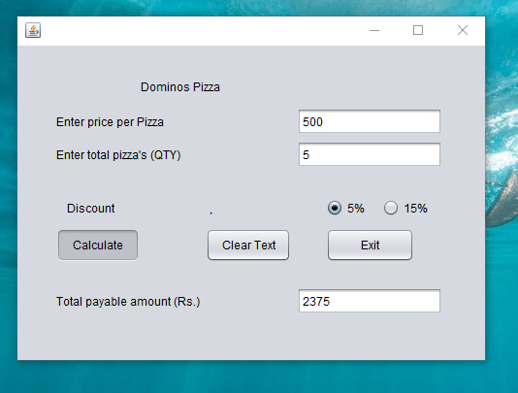

5. Design a GUI application to join your first name( TextField) and second name ( Text Field). Join these names on the click event of button “Join Names” and display them in a third Text Field (Disable).

ANS

String a = t1.getText();

String b = t2.getText();

result.setText(""+a+b);

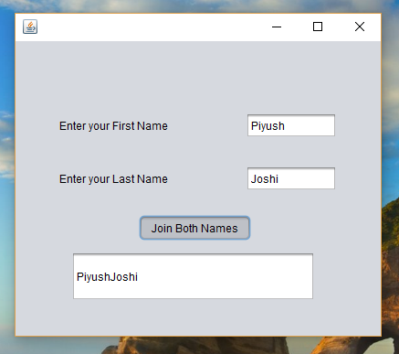

6.Design a GUI application in netbeans to calculate the amount payable by the customer as per the following GUI. The rate of extra toppings are given in the brackets and any applicable discount. You are required to write the code on the click event of “calculate bill”.

ANS

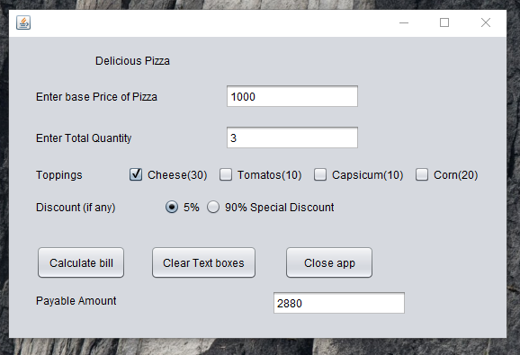

Calculate Button

Clear text button

t1.setText("");

t2.setText("");

t3.setText("");

int a = Integer.parseInt(jTextField1.getText()); //base price

int b = Integer.parseInt(jTextField2.getText()); // quantity

double c; //amount

c= a*b;

if(jCheckBox1.isSelected())

{

c=c+30;

}

if(jCheckBox2.isSelected())

{

c=c+10;

}

if(jCheckBox3.isSelected())

{

c=c+10;

}

if(jCheckBox4.isSelected())

{

c=c+20;

}

if (jRadioButton1.isSelected())

{

c=c-(c*5/100);

}

if (jRadioButton2.isSelected())

{

c=c-(c*90/100);

}

Result.setText(“ ”+c);}

7. Design a GUI application to read Roll Number, name of student and marks obtained in five subject in text Fields. Calculate Total marks and grade on the click event of “Calculate” and display them on the text Fields. The criteria to calculate grade is as follows

|  |  |
| --- | --- |
| % marks | Grade |
| >=90 | A |
| <90 and >=80 | B1 |
| <80 and >=70 | B2 |
| <70 and >=50 | C |

The GUI should be like this

ANS

String name = t1.getText();

int Num = Integer.parseInt(t2.getText());

int a = Integer.parseInt(t3.getText());

int b = Integer.parseInt(t4.getText());

int c = Integer.parseInt(t5.getText());

int d = Integer.parseInt(t6.getText());

int e = Integer.parseInt(t7.getText());

int total = a+b+c+d+e;

t8.setText(""+total);

double percentage ;

percentage = (total/5);

t9.setText(""+percentage);

float perc = Float.parseFloat(t9.getText());

char grade;

if (perc >=90){

grade = 'A';

elseif (perc >= 80)

grade = 'B1';

elseif (perc >= 70)

grade = 'B2';

else

grade = 'C';

t10.setText(grade);

}

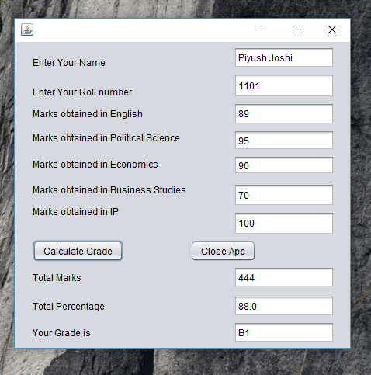

8.Design a GUI application to read three numbers ( in TextFields) from the keyboard and calculate the largest number among them. Display the result in Text Field.

ANS

int a, b, c;

int max;

a = Integer.parseInt(t1.getText());

b = Integer.parseInt(t2.getText());

c = Integer.parseInt(t3.getText());

if (a>=b && b>c)

max=a;

else if (b>=a && b>c)

max=b;

else if (c>=a && c>b)

max=c;

t4.setText(""+c);

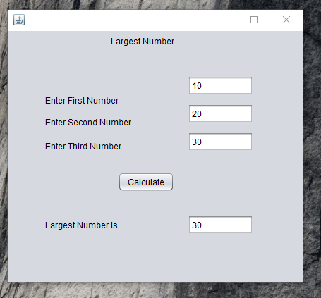

9. Design a GUI Application(Append) to read your name( Textfield) , roll Number ( TextField), Class ( TextField) marks obtained in English ( TextField), Accounts ( TextField), Business Studies (TextField), Economics ( Textfield) and informatics Practics( TextField). Using JTextArea’s Append methods display all the inputed information in TextArea on the click event of “Add Information” button.

ANS

String a = t1.getText();

int b = Integer.parseInt(t2.getText());

int c = Integer.parseInt(t3.getText());

int d = Integer.parseInt(t4.getText());

int e = Integer.parseInt(t5.getText());

int f = Integer.parseInt(t6.getText());

int g = Integer.parseInt(t7.getText());

ta1.append("Student Name:"+a+"\n");

ta1.append("Roll no:"+b+"\n");

ta1.append("English:"+c+"\n");

ta1.append("Physics:"+d+"\n");

ta1.append("Chemistry:"+e+"\n");

ta1.append("Maths:"+f+"\n");

ta1.append("IP:"+g);

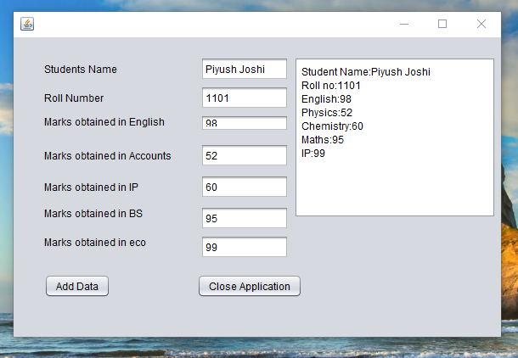

10.Design a GUI application to read starting number( TextField) and end number (Text Field). Generate all the number between these two numbers and display them in a TextArea on the click event of “generate series” button.

ANS

int a = Integer.parseInt(t1.getText());

int b = Integer.parseInt(t2.getText());

int i;

for (i = a ; i<=b ; i+=1)

{ta1.setText(ta1.getText()+i);}

Clear Button

t1.setText(“”);

t2.setText(“”);

ta1.setText(“”);

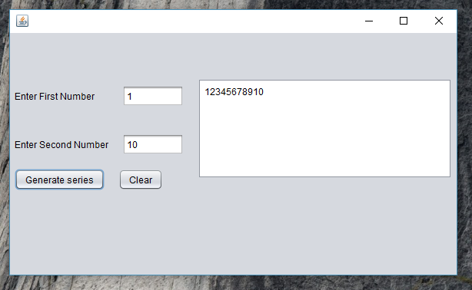

11. Create a table school in mysql with the following structure

|  |  |  |  |
| --- | --- | --- | --- |
| Field Name | Data Type | Size | Constraint |
| Admno | Char | 10 | Primary key |
| Name | Varchar | 30 | Not null |
| Class | Char | 15 |  |
| Section | Char | 1 |  |
| Fees | Char | 10 |  |

Design a GUI in netbeans to insert record in this newly created table school.

ANS

import java.sql.Connection;

import java.sql.DriverManager;

import java.sql.Statement;

private void jToggleButton1ActionPerformed(java.awt.event.ActionEvent evt) {

String a,b,c,d,e;

a=t1.getText();

b=t2.getText();

c=(String)cb1.getSelectedItem();

d=(String)cb2.getSelectedItem();

e=t3.getText();

String s1,s2,s3;

s1="jdbc:mysql://localhost:3306/piyush";

s2="root";

s3="123";

try

{

Class.forName("com.mysql.jdbc.Driver");

Connection x;

x=DriverManager.getConnection(s1,s2,s3);

String q="INSERT INTO student values('"+a+"','"+b+"','"+c+"','"+d+",'"+e+"');";

Statement y;

y=x.createStatement();

y.executeUpdate(q);

x.close();

}

catch (Exception e)

{ jLabel5.setText("Invalid");}

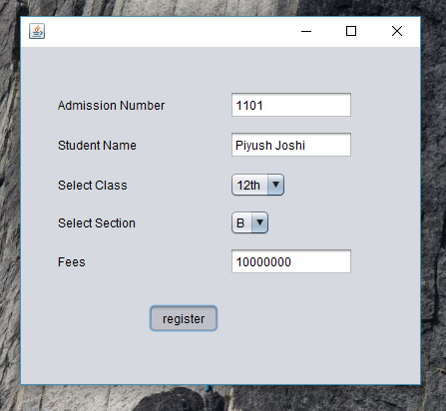

For Table

mysql> create table student

-> (adminno CHAR(10) PRIMARY KEY,

-> Name VARCHAR(30) ,

-> Class CHAR(15) ,

-> Section CHAR(1),

-> Fees CHAR(15));

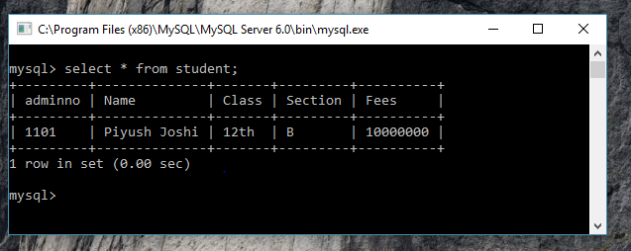

12. Create a table student in mysql with the following structure

|  |  |  |  |
| --- | --- | --- | --- |
| Field Name | Data Type | Size | Constraint |
| Admno | Char | 10 | Primary key |
| Name | Varchar | 30 | Not null |
| Class | Char | 15 |  |
| Section | Char | 1 |  |
| Fees | Char | 15 |  |

Insert 5 record in this newly created table of student. Design a GUI in netbeans to show all the records of this table in netbeans in table format

ANS

Show Details

import java.sql.Connection;

import java.sql.DriverManager;

import java.sql.ResultSet;

import java.sql.Statement;

import javax.swing.table.*;

private void jButton1ActionPerformed(java.awt.event.ActionEvent evt) {

DefaultTableModel m=(DefaultTableModel)jTable1.getModel();

try {

Class.forName("com.mysql.jdbc.Driver");

Connection x;

String S1,S2,S3;

S1="jdbc:mysql://localhost:3306/piyush";

S2="root";

S3="123";

x=(Connection) DriverManager.getConnection(S1,S2,S3);

Statement y=x.createStatement();

String q="SELECT *FROM student";

ResultSet r = y.executeQuery(q);

while(r.next())

{

int a=r.getInt(1);

String b=r.getString(2);

int c=r.getInt(3);

String d=r.getString(4);

int e=r.getInt(5);

m.addRow(new Object[]{a,b,c,d,e});

}

x.close();

}

catch(Exception e)

{}

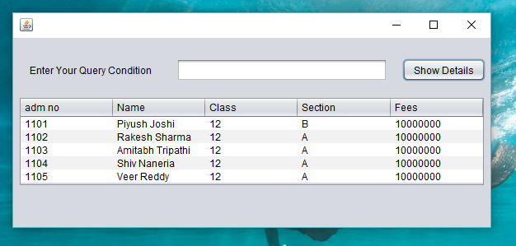

13. Design a GUI in netbeans to search a record in the above generated table student. If the record exist then delete that record from the table

.

Search Button

String a=t1.getText();

try {

Class.forName("com.mysql.jdbc.Driver");

Connection x;

String S1,S2,S3;

S1="jdbc:mysql://localhost:3306/piyush";

S2="root";

S3="123";

x=(Connection) DriverManager.getConnection(S1,S2,S3);

Statement y=x.createStatement();

String q="SELECT *FROM student"

+ "WHERE adminno='"+a+"';";

ResultSet r=y.executeQuery(q);

r.next();

if(r!=null)

{t2.setText(r.getString(2));

t3.setText(r.getString(3));

t4.setText(r.getString(4));

t5.setText(r.getString(5));

jButton2.setEnabled(true);

}

else{jLabel5.setText("Record not exist");

}

x.close();

}

catch(Exception e)

Delete Button

String a=jTextField1.getText();

try {

Class.forName("com.mysql.jdbc.Driver");

Connection x;

String S1,S2,S3;

S1="jdbc:mysql://localhost:3306/piyush";

S2="root";

S3="123";

x=(Connection) DriverManager.getConnection(S1,S2,S3);

Statement y=x.createStatement();

String q="DELETE FROM student WHERE adminno='"+a+"';";

ResultSet r=y.executeupdate(q);

x.close();

}

catch(Exception e)

{}

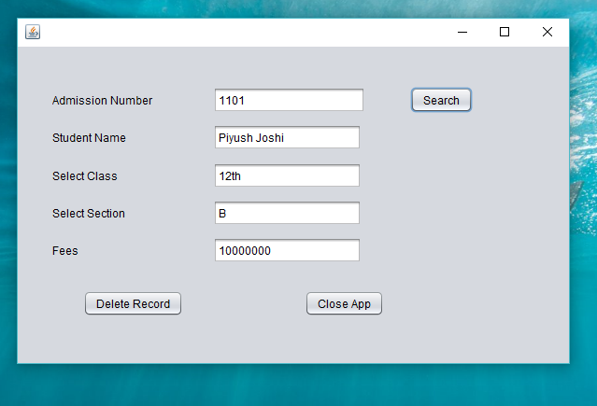

Close Button

this.dispose();

14. Design a GUI in netbeans to search a record in the above generated table student. If the record exist then UPDATE that record from the table ( Screenshot is for reference purpose) otherwise display a popup message “record does not exist”. Modify button only enable if the record exist in the database otherwise it remains disable.

ANS

Search Button

private void jButton1ActionPerformed(java.awt.event.ActionEvent evt) {

String a=t1.getText();

try {

Class.forName("com.mysql.jdbc.Driver");

Connection x;

String S1,S2,S3;

S1="jdbc:mysql://localhost:3306/piyush";

S2="root";

S3="123";

x=(Connection) DriverManager.getConnection(S1,S2,S3);

Statement y=x.createStatement();

String q="SELECT *FROM student WHERE adminno='"+a+"';";

ResultSet r=y.executeQuery(q);

r.next();

if(r!=null)

{t2.setText(r.getString(2));

t3.setText(r.getString(3));

t4.setText(r.getString(4));

t5.setText(r.getString(5));

jButton2.setEnabled(true);

}

else{ JOptionPane.showMessageDialog(null, "Record Does not exist");

}

x.close();

}

catch(Exception e)

{}

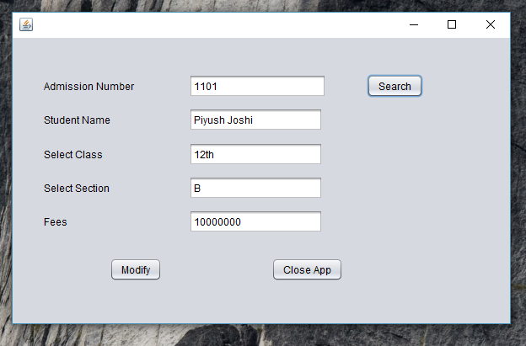

15. ABN Corporation impose charges on customer for different products .The shipping company costs for an order in two forms 1.- Wholeseller 2- retailer. The cost is calculated on unit basis as follows

|  |  |  |
| --- | --- | --- |
| Units | Price per unit(wholeseller) | Price per unit ( Retailer) |
| 1-15 | Rs. 50 | Rs.55 |
| 16-20 | 45 | 50 |
| 21-30 | 40 | 45 |
| 21-50 | 35 | 40 |
| >50 | 30 | 35 |

Special customers ( checkbox ) are given 10% extra discount. The following is the screenshot used to calculate cost for order.

Jpanel container is used for customer type as two radio buttons are hosted on this container. Wholesale and Retailer.

You are required to calculate “Discount” and total cost on the click event of “Calculate” button and also display discount and total cost in textfields.

ANS.

Calculate Button

int x=Integer.parseInt(t1.getText());

double t=0;

double d=0;

if(jRB1.isSelected()==true)

{if(x<=15)

{t=x*50;}

if(x<=20&&x>=16)

{t=x*45;}

if(x<=30&&x>=21)

{t=x*40;}

if(x<=50&&x>=31)

{t=x*35;}

if(x>50)

{t=x*30;}

}

if(jRB1.isSelected()==true)

{if(x<=15)

{t=x*55;}

if(x<=20&&x>=16)

{t=x*50;}

if(x<=30&&x>=21)

{t=x*45;}

if(x<=50&&x>=31)

{t=x*40;}

if(x>50)

{t=x*35;}

}

if(CB1.isSelected()==true)

{d=t*0.1;}

double a=t-d;

T2.setText(""+d);

T3.setText(""+a);

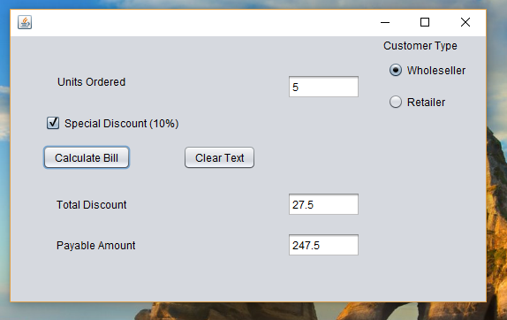

**16.** Mr XYZ visited mahagun mega mall. His family purchased some products form mahagun metro mall. The mall have some attractive discount for credit cards holders. You are requested to calculate the discount on total amount ( enter in text field) and calculate discount as per the criteria table given below

|  |  |
| --- | --- |
| Card Company Name | % discount offered |
| HDFC | 12% |
| ICICI | 15% |
| CITY BANK | 10% |
| VISA | 14% |
| Master Card | 18% |

Please referrer the following image for more details

Calculate Discount and Bill

int x=Integer.parseInt(t1.getText());

double d=0;

if(jRadioButton1.isSelected()==true)

{d=x*0.12;}

if(jRadioButton2.isSelected()==true)

{d=x*0.15;}

if(jRadioButton3.isSelected()==true)

{d=x*0.10;}

if(jRadioButton4.isSelected()==true)

{d=x*0.14;}

if(jRadioButton5.isSelected()==true)

{d=x*0.18;}

double t=x-d;

t2.setText(""+d);

t3.setText(""+t);

Close Button

System.exit(0);

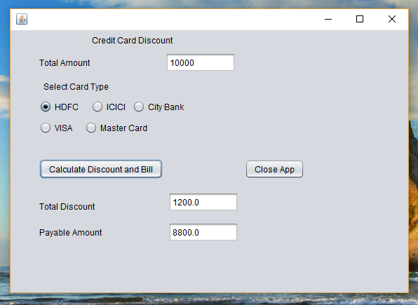

**17.** Ms Vidhyarthi is Working in DAV Centenary Public School Chander Nagar as a programmer. She was asked to develop a GUI in netbeans to develop an application. The school offers two streams – 1 Medical 2- Non Medical with the following grading criteria.

|  |  |  |
| --- | --- | --- |
| Stream | Percentage | Grade |
| Medical | >=80 | A |
|  | 60-79 | B |
|  | <60 | C |
| Non-Medical | >=75 | A |
|  | <75 and >=50 | B |
|  | <50 | C |

The school also offers special incentive to NCC cadets in the form of 3% increment in percentage for all the NCC cadets.

**ANS**

Grade button

int x=Integer.parseInt(jTextField1.getText());

int y=Integer.parseInt(jTextField2.getText());

double a=(x+y)/2;

if(jCheckBox1.isSelected()==true)

{a=a+3;}

jTextField3.setText(""+a);

if(jRadioButton1.isSelected()==true)

{if(a>=80)

{jTextField4.setText("A");}

if(a>=60&&a<=79)

{jTextField4.setText("B");}

if(a<60)

{jTextField4.setText("C");}

}

if(jRadioButton2.isSelected()==true)

{if(a>=75)

{jTextField4.setText("A");}

if(a>=50&&a<=75)

{jTextField4.setText("B");}

if(a<50)

{jTextField4.setText("C");}

}

Percentage Button

int x=Integer.parseInt(jTextField1.getText());

int y=Integer.parseInt(jTextField2.getText());

double a=(x+y)/2;

if(jCheckBox1.isSelected()==true)

{a=a+3;}

jTextField3.setText(""+a);

Clear button

jTextField1.setText("");

jTextField2.setText("");

jTextField3.setText("");

jTextField4.setText("");

